Image reconstruction via the Fourier and Haar transforms.

We investigate how the structure of different images affects their representation in Fourier and Haar wavelet bases. The constructed images each possess unique characteristics such as periodicity, smooth and abrupt variations, and geometric symmetry.
The images are transformed into Fourier and Haar coefficient representations, after which only a specified proportion of the largest magnitude coefficients are retained. The images are then reconstructed from these reduced representations (more specifically, from only 0.1% and 10% of the coefficients), and the mean squared error (MSE) is plotted.
We begin with a brief mathematical description of the bases of two transforms and the method used to obtain the compressed representations through each of them.

- The Discrete Fourier Transform
We begin with an orthonormal basis defined as follows:

$$ϕ_{k}=\frac{1}{\sqrt{N}}e^{2πikn/N}$$

$$where n,k=0,1,...,N-1$$

If $\overset{⃑}{x }$ represents a vector in space, then the Fourier coefficient corresponding to $ϕ_{k}$ is obtained by taking the inner product of the signal with the basis function.

$$c_{k}=\left\langle \overset{⃑}{x},ϕ_{k}\right\rangle$$

Thus, the Fourier transform here can be understood as a change of basis, and rather than representing a vector by its value at each position, we represent it by its coefficients w.r.t the Fourier basis.

For an image, we extend the same idea but in two dimensions. We begin by applying the transform along either the columns or rows first, then along the other. This way, we obtain a matrix of spatial frequencies.

The Fast Fourier Transform (FFT)

The Fast Fourier Transform is an algorithm that substantially reduces both the time and computational resources required to calculate the Discrete Fourier Transform. The algorithm utilises the symmetry in roots of unity appearing in the DFT, in particular, their periodicity. The DFT can be separated into even and odd elements, and the original N-dim DFT can be expressed in terms of N/2 -dim DFTs. This can continue until only a 2-point transform remains.

The resulting reduction in the number of calculations is particularly important for image processing, as images often contain a very large number of pixels. Without the FFT, computational speeds the process would be computationally expensive and impractical.

- Haar Transform

The Haar wavelet is constructed from localised functions, and in one dimension, the Haar basis consists of the vectors.
$$h_{0}=\frac{1}{\sqrt{2}}\left(1,1\right)$$
$$h_{1}=\frac{1}{\sqrt{2}}\left(1,-1\right)$$

The father wavelet is the function
$$φ(x)=\left\{\begin{aligned}1, &if 0≤x<1 \\ 0, &otherwise\end{aligned}\right.$$
while the mother wavelet is
$$θ(x)=\left\{\begin{aligned}1 0≤x<\frac{1}{2} \\ -1 \frac{1}{2}≤x≤1 \\ 0 otherwise\end{aligned}\right.$$

We continue this way with each division, introducing a scaled and shifted version of the mother wavelet as we go on.

In two dimensions, the Haar transform is obtained by applying the one-dimensional Haar transform independently in the horizontal and vertical directions. The rows and columns of the resulting coefficient matrix have a different interpretation from the Fourier coefficient matrix. Rather than the combinations of the horizontal and vertical spatial frequencies, we instead interpret them (when level=1) as an approximation coefficient matrix and 3 detail coefficient matrices.

Unlike the Fourier basis which extends across the image, the Haar basis is localised. This gives more information about where certain image features occur, allowing at times for a better representation of local changes. This will play a role as we shall see in the quality of image reconstructions via wavelets.

Image Reconstructions

Once the coefficients have been calculated, the original image can be reconstructed by reversing the change in basis. If all coefficients are retained, we get back the original image, with negligible error.

To prevent any distortion from standard image compression from interfering with the data, the images were all generated mathematically in matplotlib.

If our image is taken to be in the basis ${\{ϕ}_{k}\} ,$ then the original image can be written as

$$X=\sum_{k}{c_{k}}ϕ_{k},$$

where $c_{k}$ are the coefficients associated with the basis vectors ${\{ϕ}_{k}\}$. If only a certain percentage of these coefficients are retained, then our reconstructed image is

$$\overset{˜}{X}=\sum_{k∈S}{c_{k}}ϕ_{k}$$

where S is a subset of the original set of indices.

The coefficients are ordered by magnitude, and the p% largest-magnitude coefficients are preserved while the others are discarded. The reconstructed test images are all derived from just 0.1% of coefficients. We also calculate the mean squared error at different percentages.

The percentage values (p) are [0.1, 0.5, 1, 2, 5, 10, 15, 20, 30, 40, 50,60, 70, 80, 90, 100]

We will first begin with a comparison between FFT and Haar wavelet compression in the smooth gradient image and the sharp gradient image:

- Smooth & Sharp Gradient Images
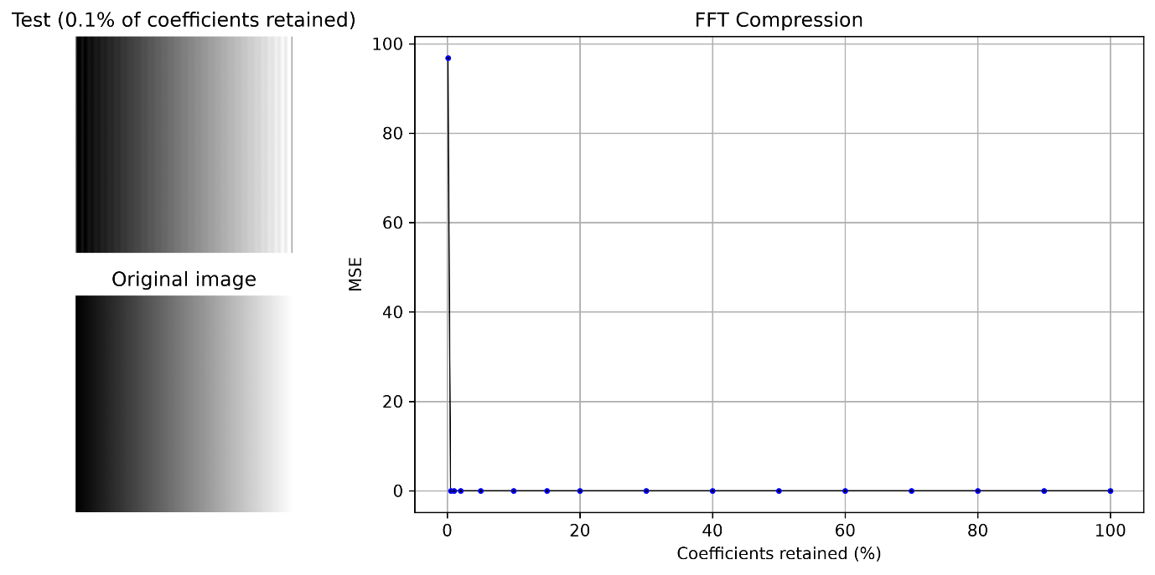

Figure 1
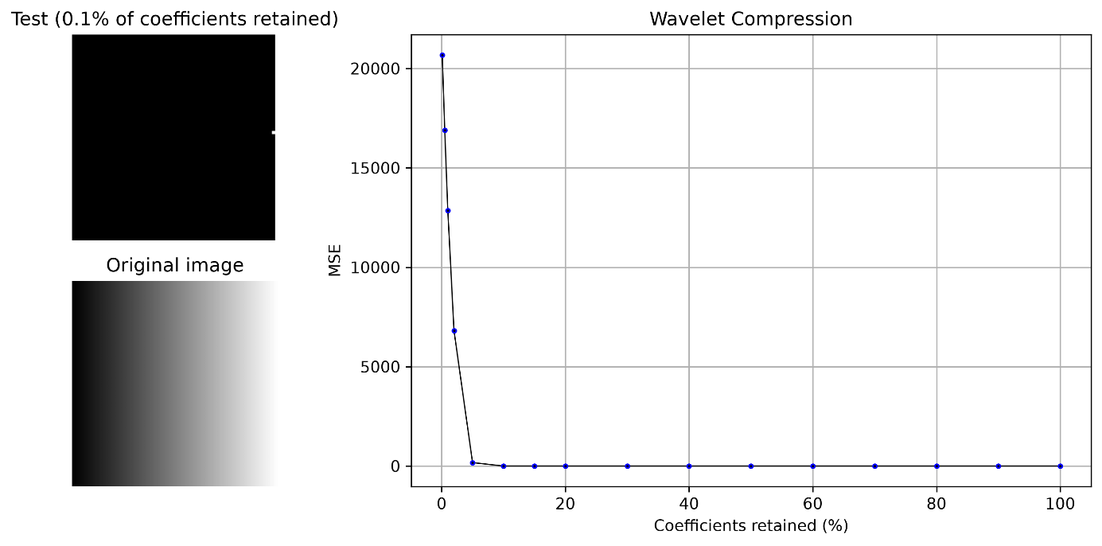

Figure 2
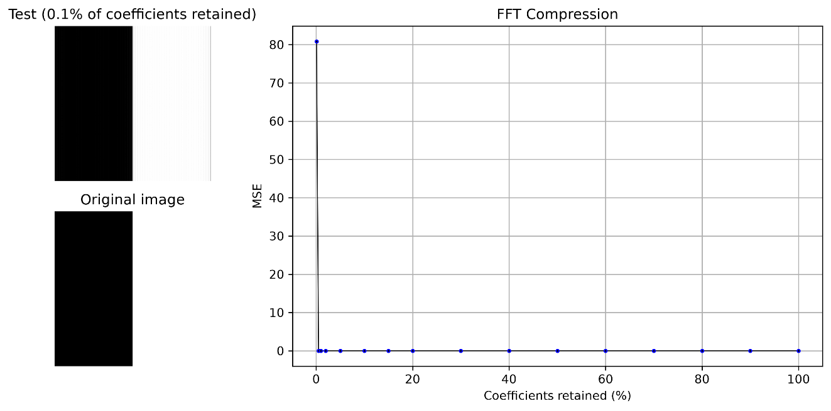
Figure 3
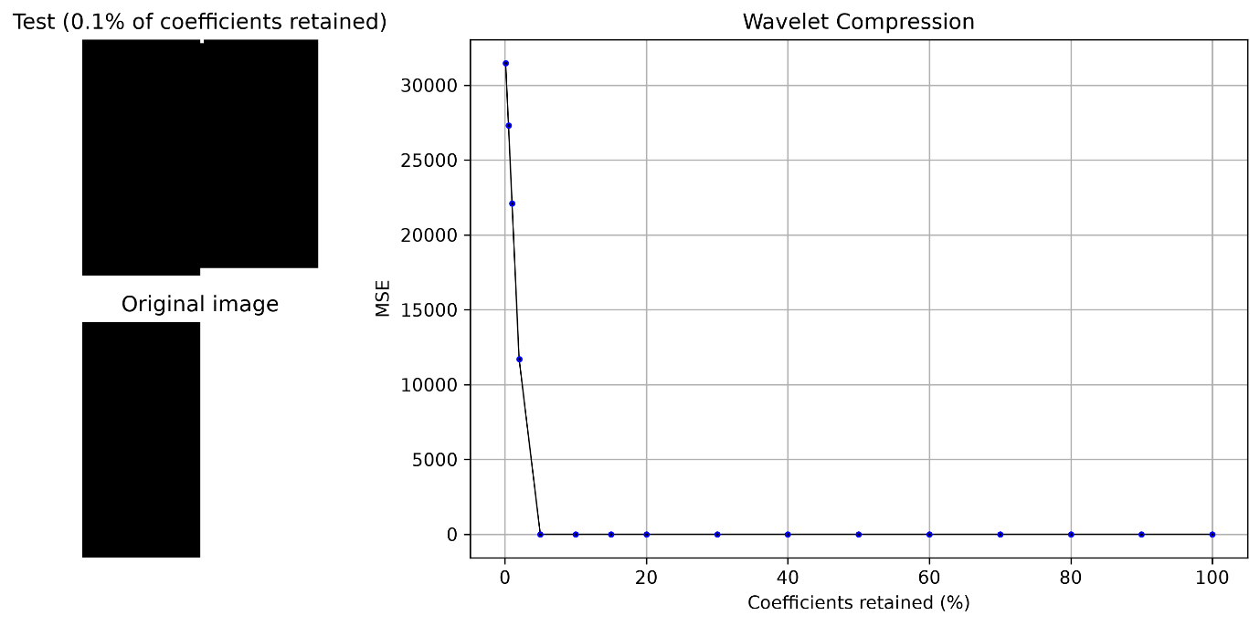
Figure 4
For the smooth and sharp gradient images above, the FFT produced a very accurate reconstruction even at low coefficient retention, with negligible MSE after 0.1%. In contrast, the wavelet reconstruction performed considerably worse at 0.1% retention. The MSE decreased progressively as more coefficients were retained, with noticeable improvements up to 5%, beyond which MSE became negligible.
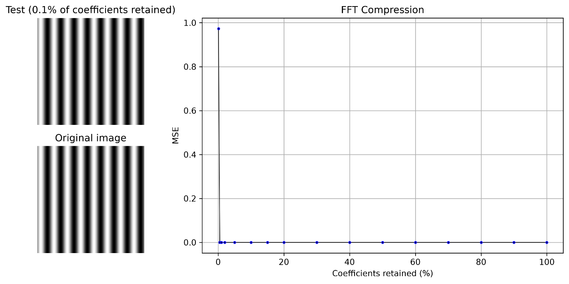
- Sine waves
Figure 5

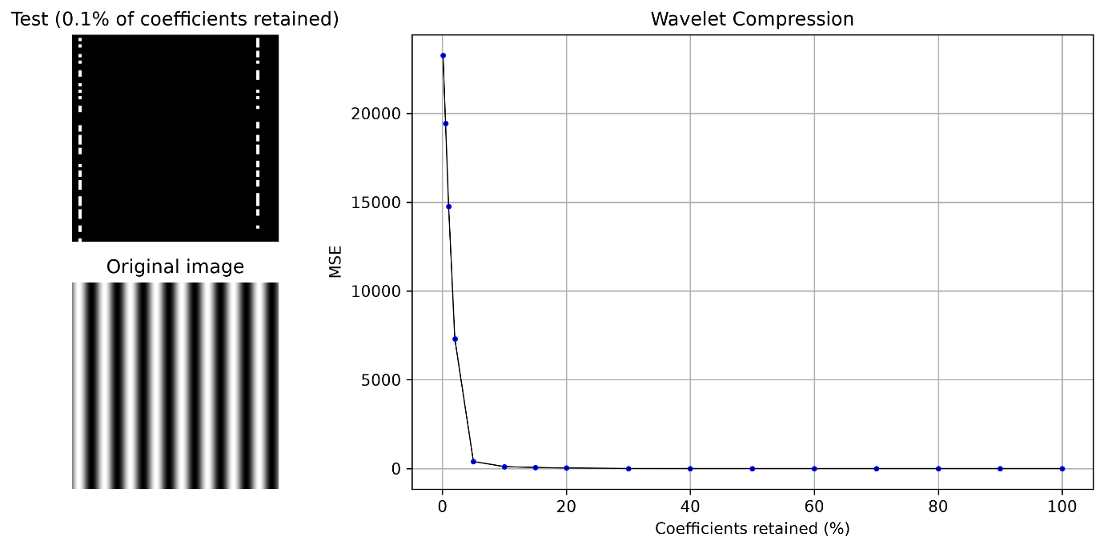
Figure 6
From the sine wave image, we obtained the expected results. The FFT provided a highly accurate reconstruction, with a negligible reconstruction error even at the 0.1%. This reflects the suitability of the Fourier basis for representing periodic image components such as sine waves. In comparison, the wavelet reconstruction performed poorly at such low percentages, and we only get a better MSE from the 5% level onwards.

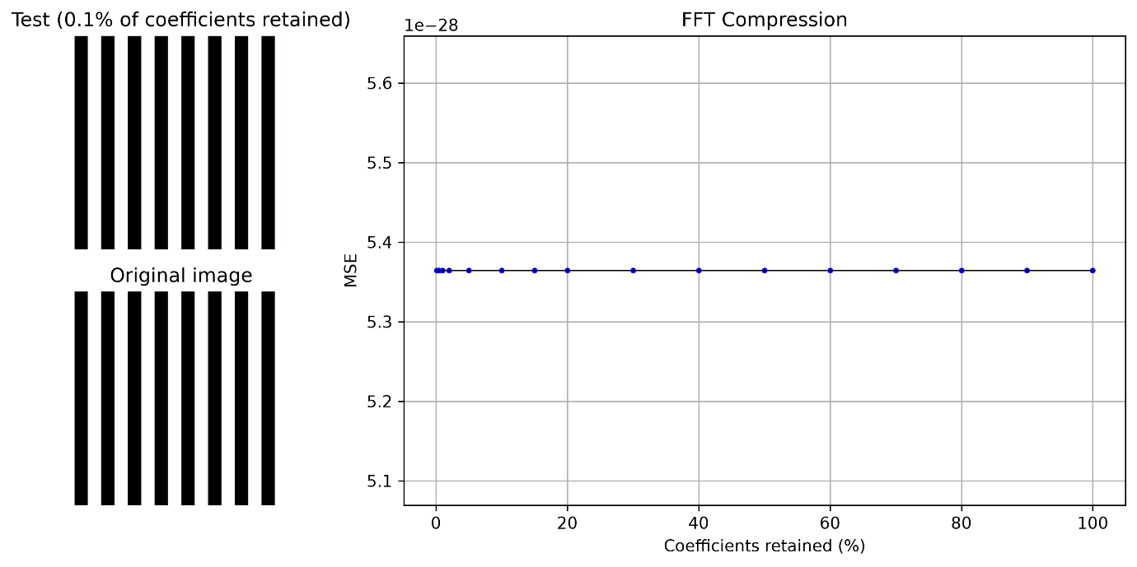
- Stripes and Checkerboard patterns

Figure 7

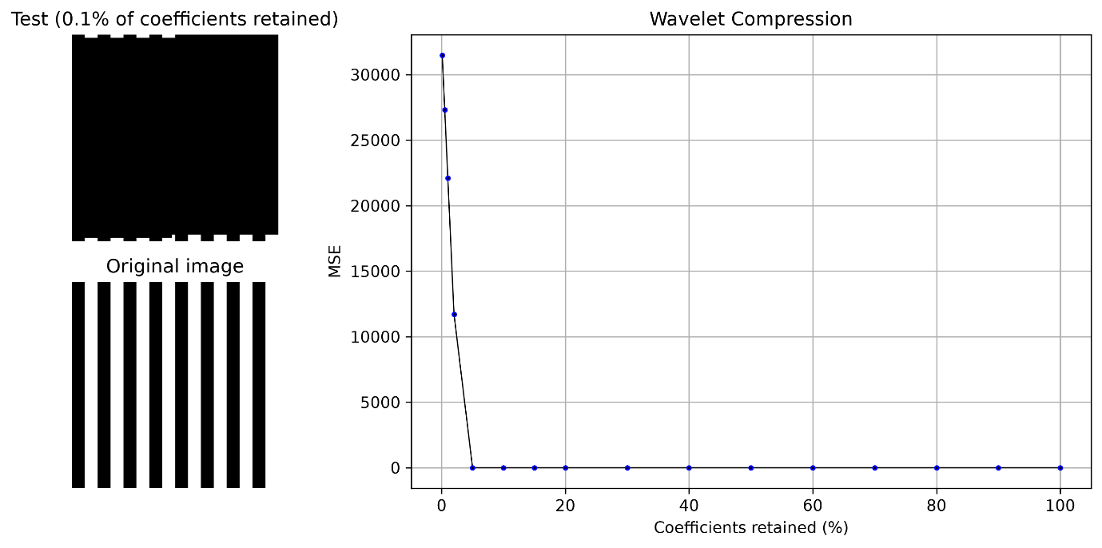
Figure 8

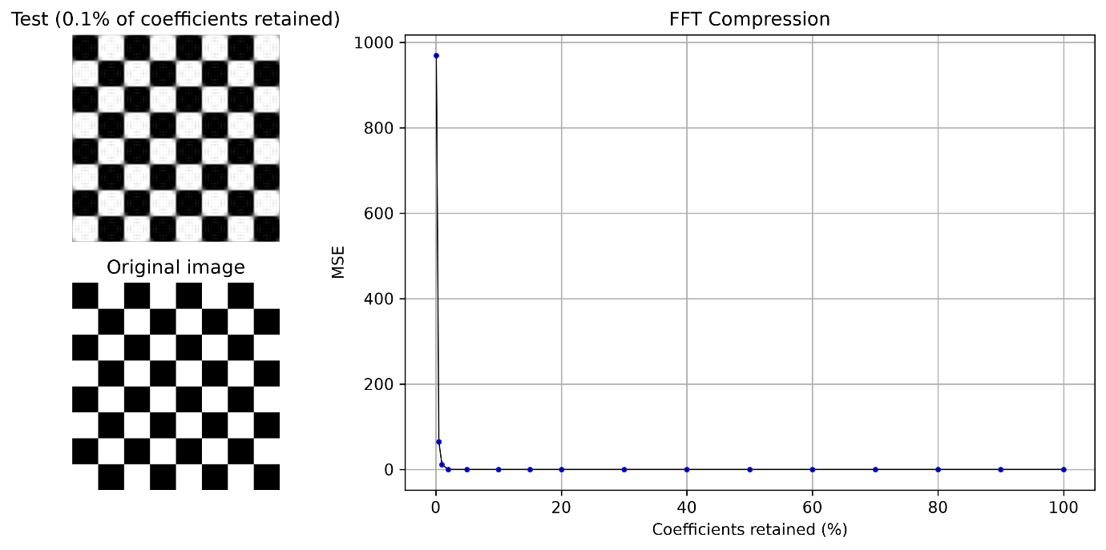

Figure 9

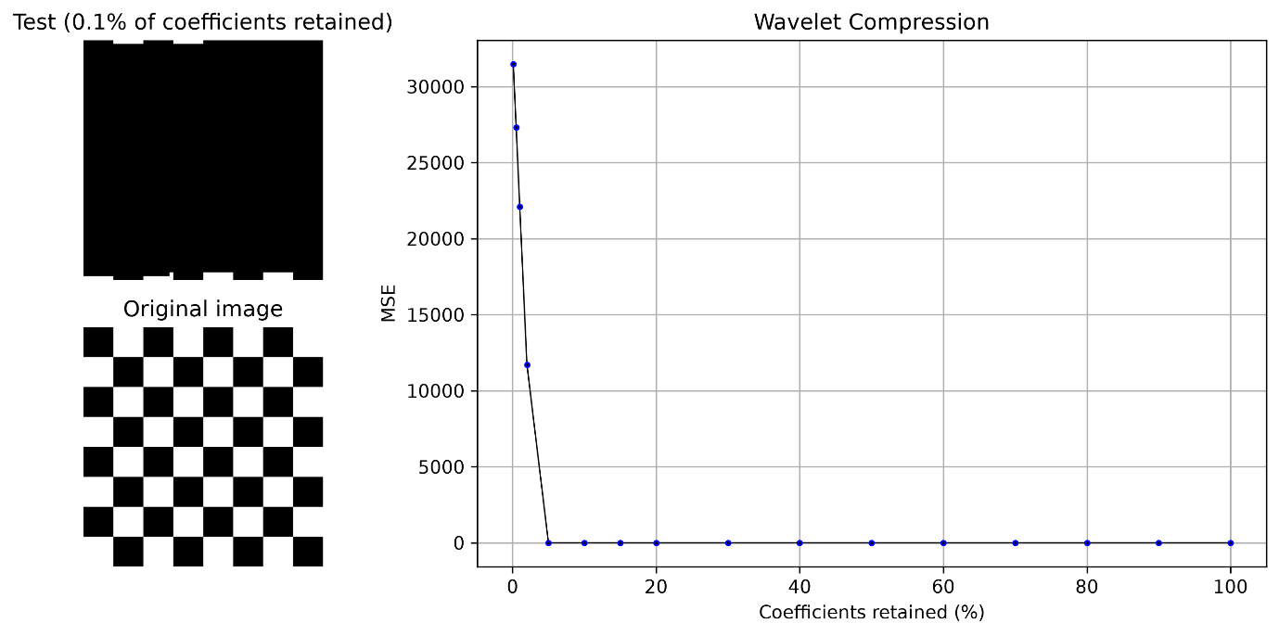
Figure 10
From Figure 7, we can see that the FFT provides almost an exact reconstruction of the stripe image with an MSE in the order of ${10}^{-28}$ for all percentage values. In contrast, the wavelet reconstructions (Figure 8) gave large errors up until the 5% level.

4. Triangle

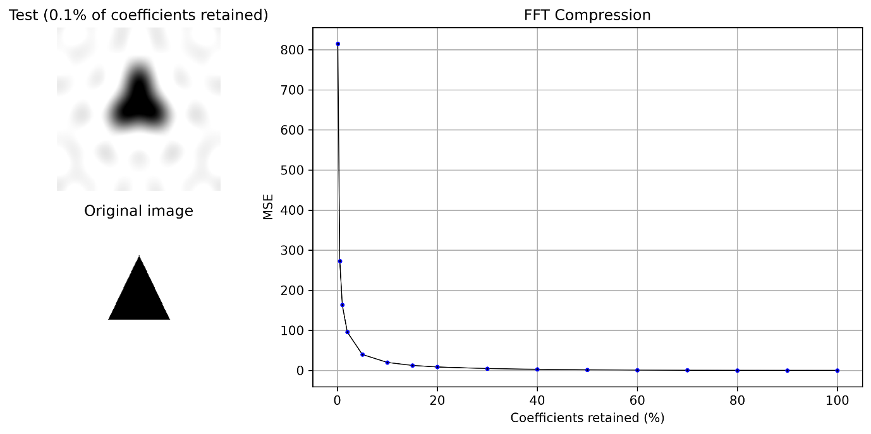
Figure 11

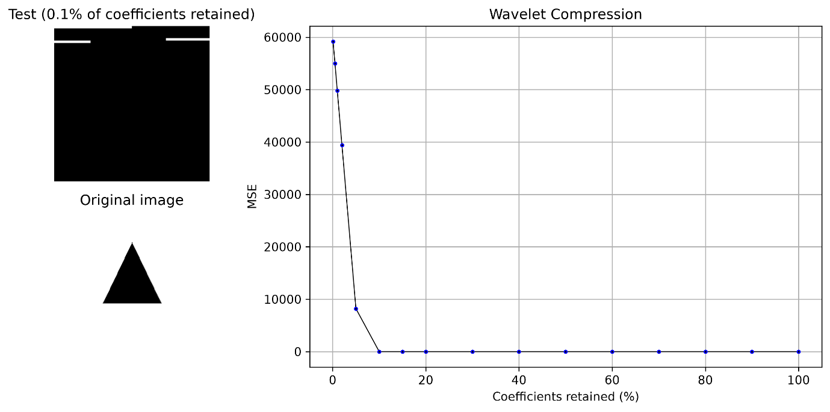
Figure 12
From Figure 12, we can see that the MSE drops sharply after 5%, though the MSE of the first five percentages is relatively high in comparison to those values in figure 11 for the same image.

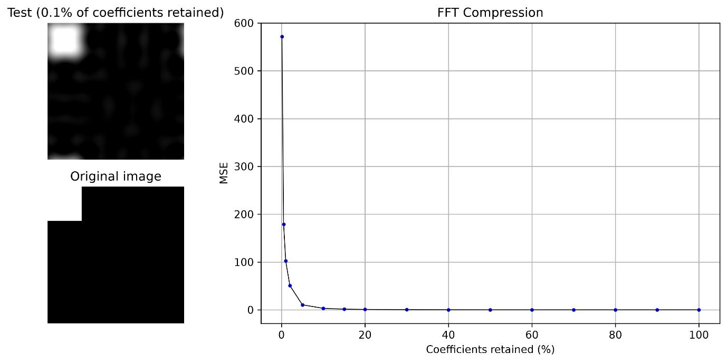
5. Corner Square

Figure 13

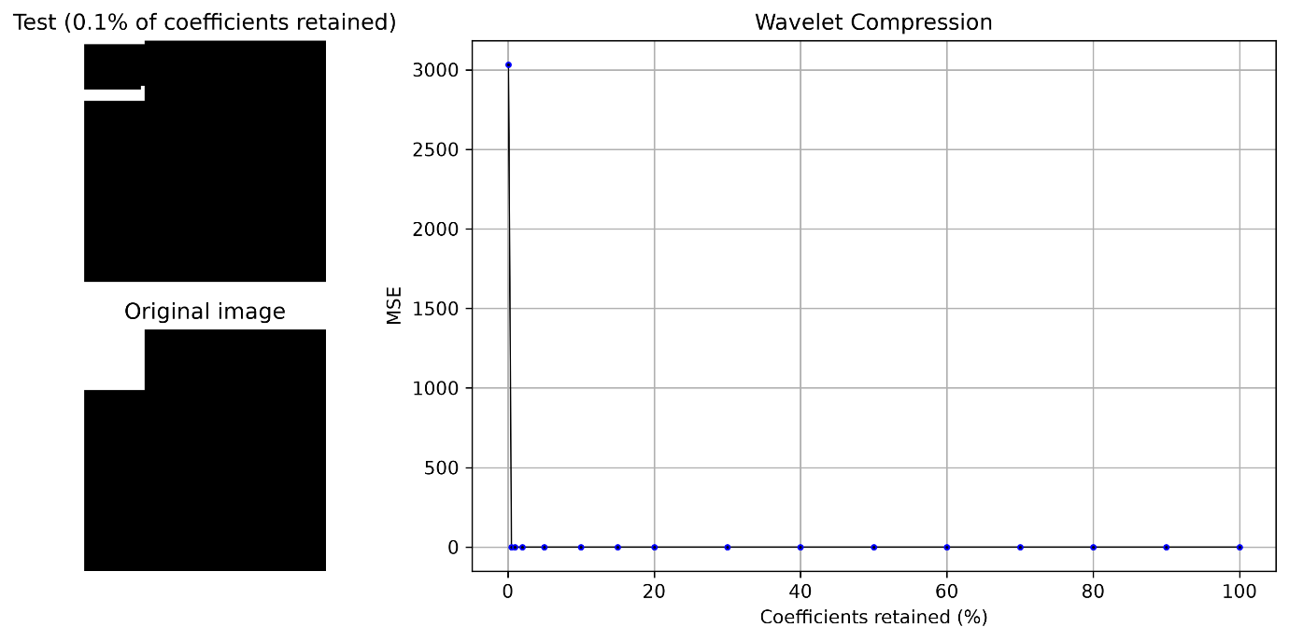
Figure 14
With this corner square image (Figures 13 and 14), we’re provided with a notable contrast to the previous results. The wavelet transform produces a more accurate representation with a negligible MSE for the percentage values greater than 0.1%. This suggests that the localised nature of the wavelet basis is better suited for representing sharp boundaries and confined shapes in images.

6. Circle

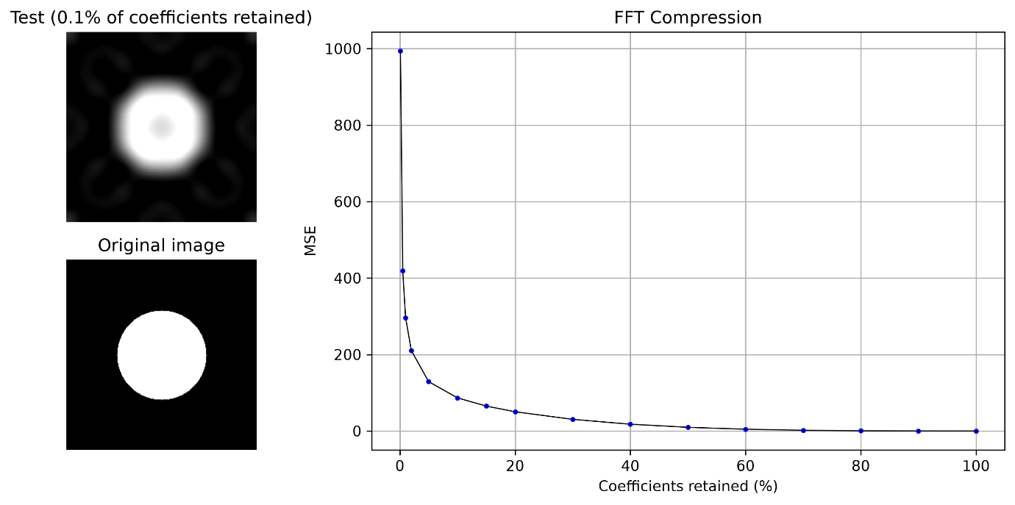
Figure 15
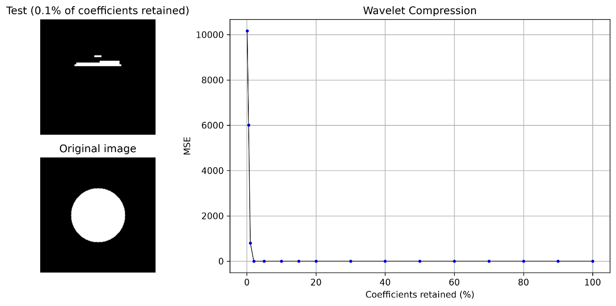Figure 16
For the circle image reconstructed via wavelets (Figure 16), we get a clearer idea of the wavelet image-compression process. As the proportion of retained coefficients increases, the MSE drops sharply in comparison to Figure 15. This demonstrates how the wavelet representation distributes information across different scales, allowing the image to be reconstructed progressively as more coefficients are retained.

7. Random Noise

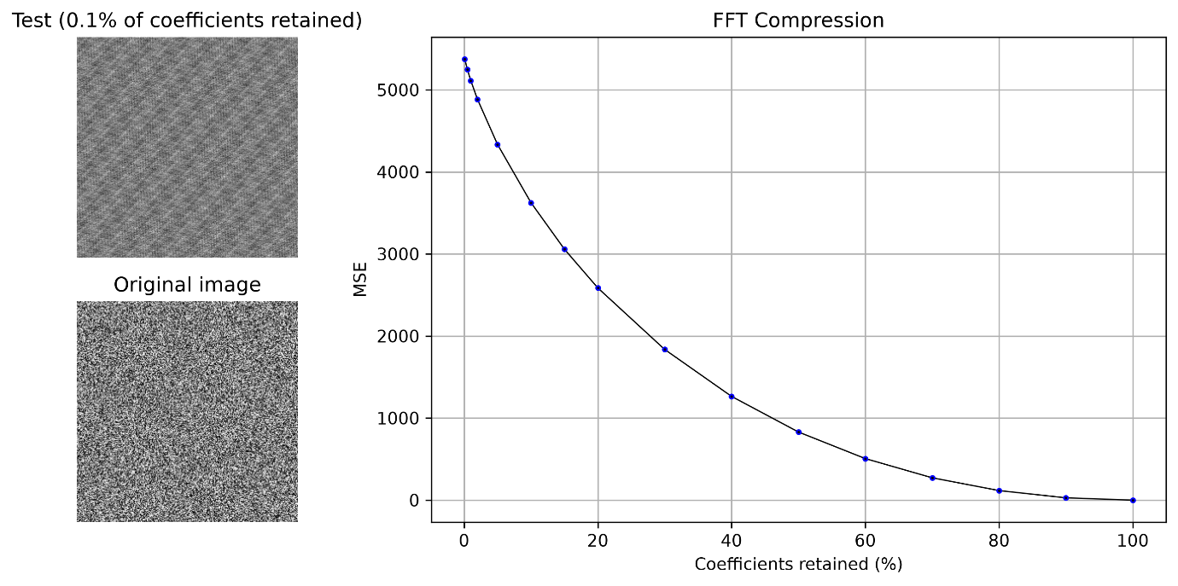
Figure 17

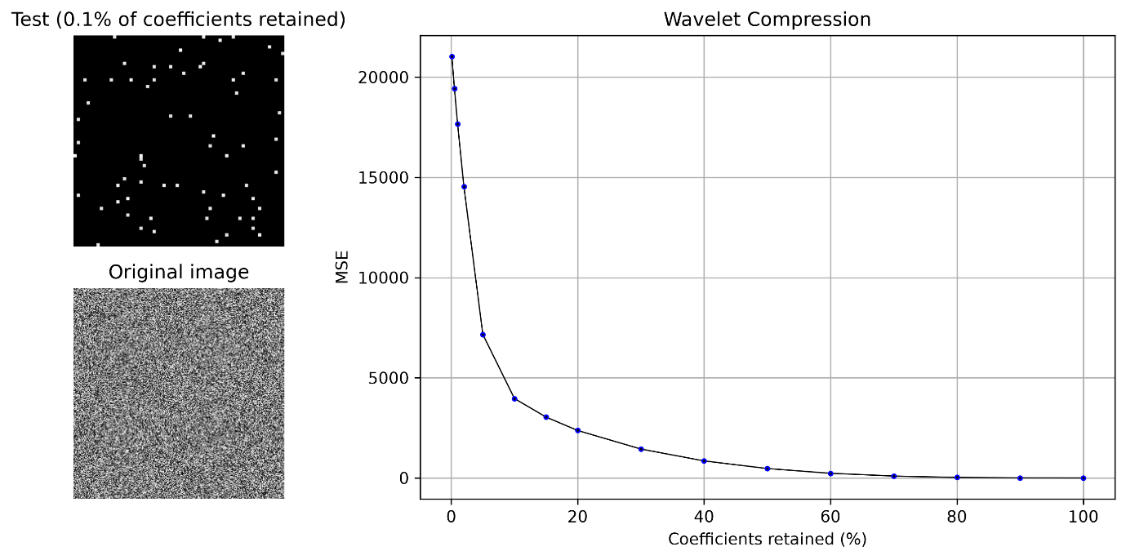
Figure 18
The MSE plotted through both methods decreases with a less steep gradient as the proportion of retained coefficients increases. Though the FFT does initially reconstruct the image with a lower MSE than the wavelet transform, the shallow decrease in both curves demonstrates that neither method is particularly effective at compressing random noise with a high degree of accuracy. A relatively large percentage must therefore be retained before a substantial reduction in MSE.

Summary
Overall, the results demonstrate the effectiveness of the Fourier and wavelet compression methods depends on the structure of the image. For smooth gradients, sharp gradients, and periodic patterns, the FFT performs well, and this is consistent with the Fourier basis’ ability to represent images with periodic aspects.
The wavelet transform performed better for the corner-square image, and this can be understood as being due to the localised nature of the wavelet basis. The circle image also demonstrated how wavelets can represent localised features. However, for images with information distributed across many coefficients, both methods showed a much gradual decrease in MSE.

